RED – 1ST PRIORITY

PINK – 2ND PRIORITY

GREEN – DONE

DESTROY SESSION WHEN TAB CLOSES!!

A.1 Purchase Request:

- Find Mode: meron sa upper right(For Remove) and meron din sa Tool Bar. Done

- Series: san mo kinukuha to? Pag primary may naka-auto na dapat. Done

- In Find mode:

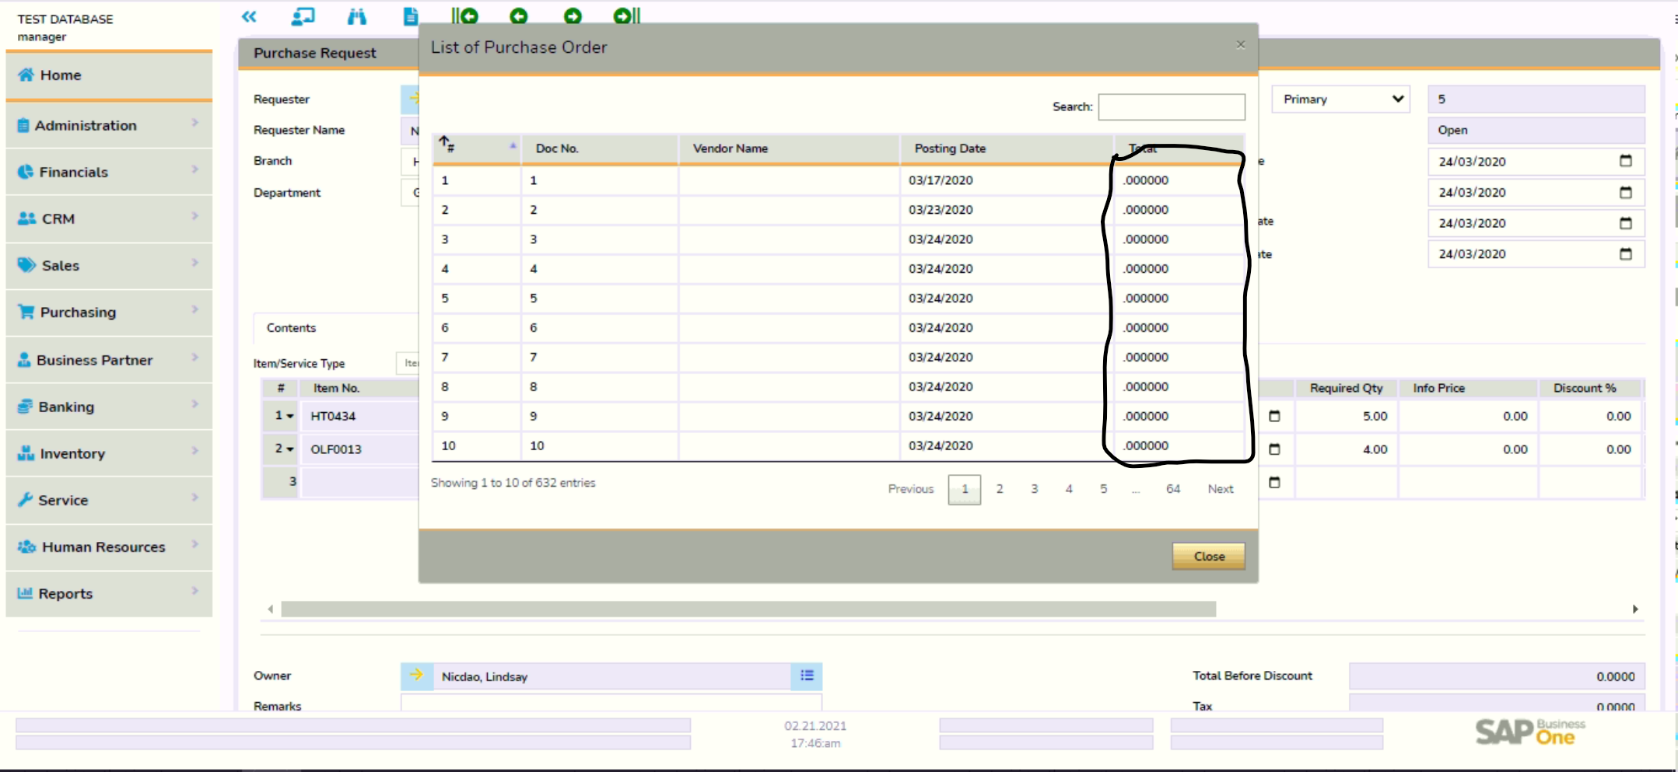

-- Dapat nasa right side and same format sa SAP. “0.00” Done

-- Nag error upon adding; error – walang department. Dapat kahit walang department pwede mag add. Solved, dapat may user nakatag kay employee

-- Nag error upon adding; error – walang encoded na price. Dapat kahit walang price pwede ma-add Done

-- Nag error upon adding; error – No Matching Records Found ODBC [2028] dapat may user nakatag kay employee

-- In Modal, Show Document Status. Done

-- Requestor should always be Employee not User in Drop down of SAP. Done

A.2 PURCHASE ORDER

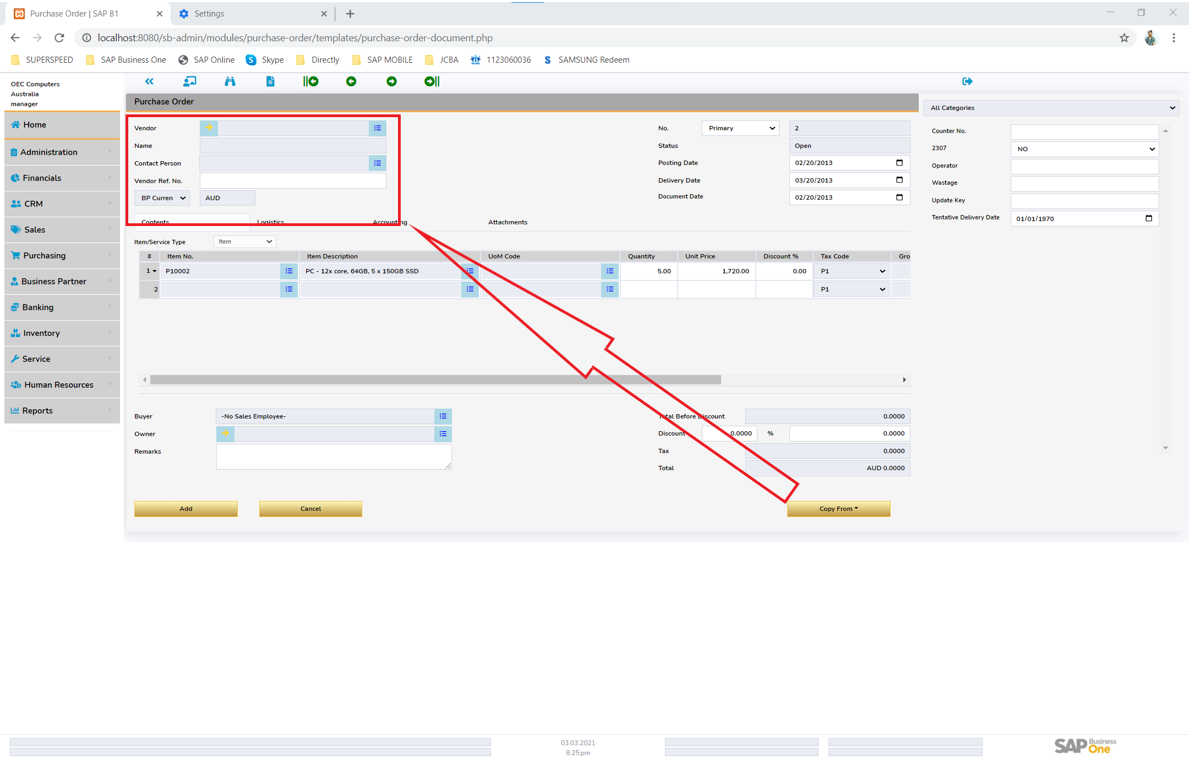

-- Nag copy from ako ng PR, Nawala yung Vendor Details. Done

-- [Copy From] SalesEmployee; Remove mandatory value or use Default in OCRD Done

A.3 Goods Receipt PO – PRIORITY Done

-- Batch/Serial Setup if OITM.MngbySerial |Batch is Yes – Mandatory Done

-- Warehouse not showing

-- buttons for item whse etc, disabled (use closed condition on lines)

-- Journal Entry Preview [Modal]

A.4 RETURN REQUEST - PRIORITY

-- Batch/Serial Tagging if OITM.MngbySerial |Batch is Yes – Mandatory

A.5 RETURN - PRIORITY

-- Batch/Serial Tagging if OITM.MngbySerial |Batch is Yes – Mandatory

-- Journal Entry Preview [Modal]

A.6 A/P DOWN PAYMENT REQUEST - PRIORITY

A.7 A/P DOWN PAYMENT INVOICE - PRIORITY

-- With Holding Computation: OWHT & WHT1 – If WTaxTable is Yes

-- Journal Entry Preview [Modal]

-- Copy to: A/P Credit Memo

A.8 A/P INVOICE - PRIORITY

-- With Holding Computation: OWHT & WHT1 – If WTaxTable is Yes

-- Journal Entry Preview [Modal]

-- Footer: Total Down Payment: [Modal]

A.9 A/P CREDIT MEMO - PRIORITY

-- With Holding Computation: OWHT & WHT1 – If WTaxTable is Yes

-- Journal Entry Preview [Modal]

A.10 SALES QUOTATION:

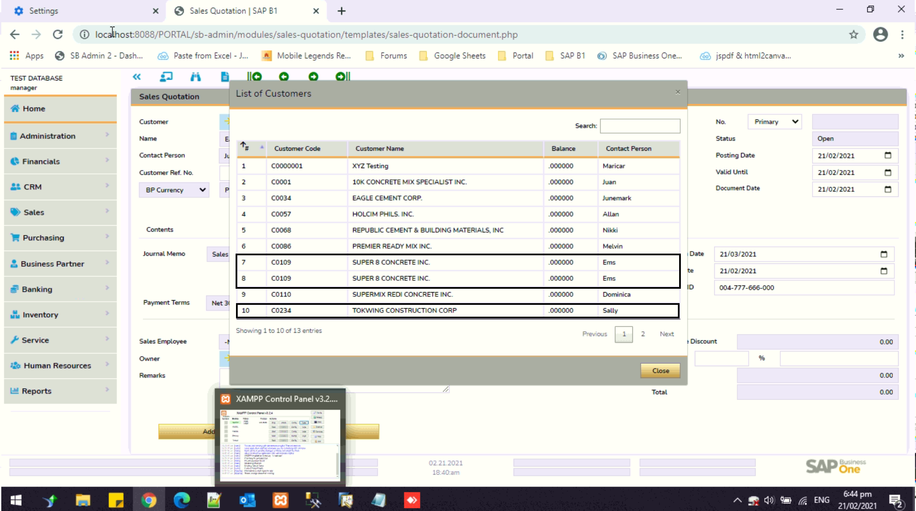

- In Customer List, it shows some duplicates business partners. Done

-- Customer List, Balance must be in Right Side with a format of “0.00” same with SAP Business One

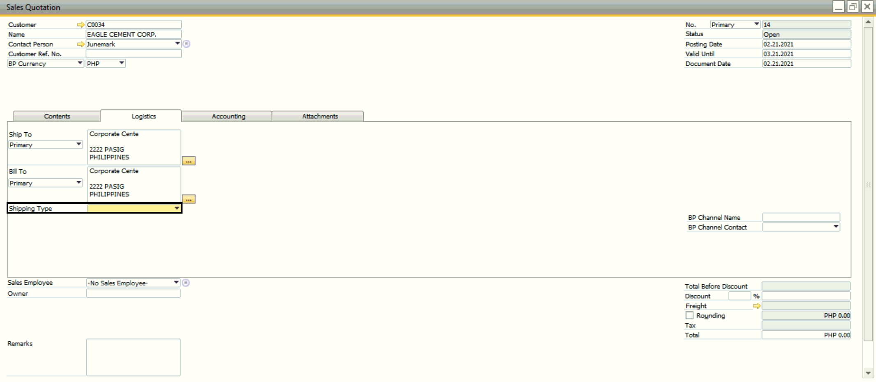

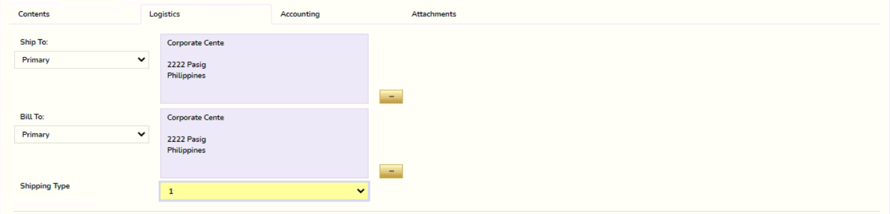

- Shipping Type; Must be default to what is inputed in BP Master Data Done

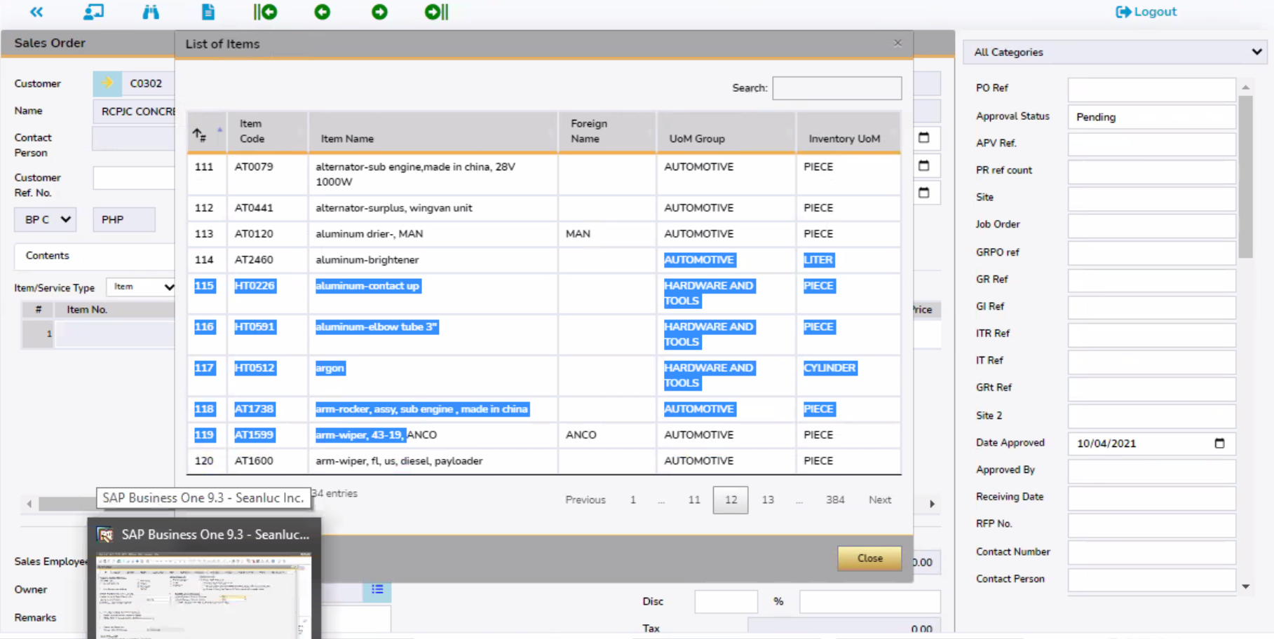

-- Item Group not UoM Group, please check other Modules

A.11 SALES ORDER

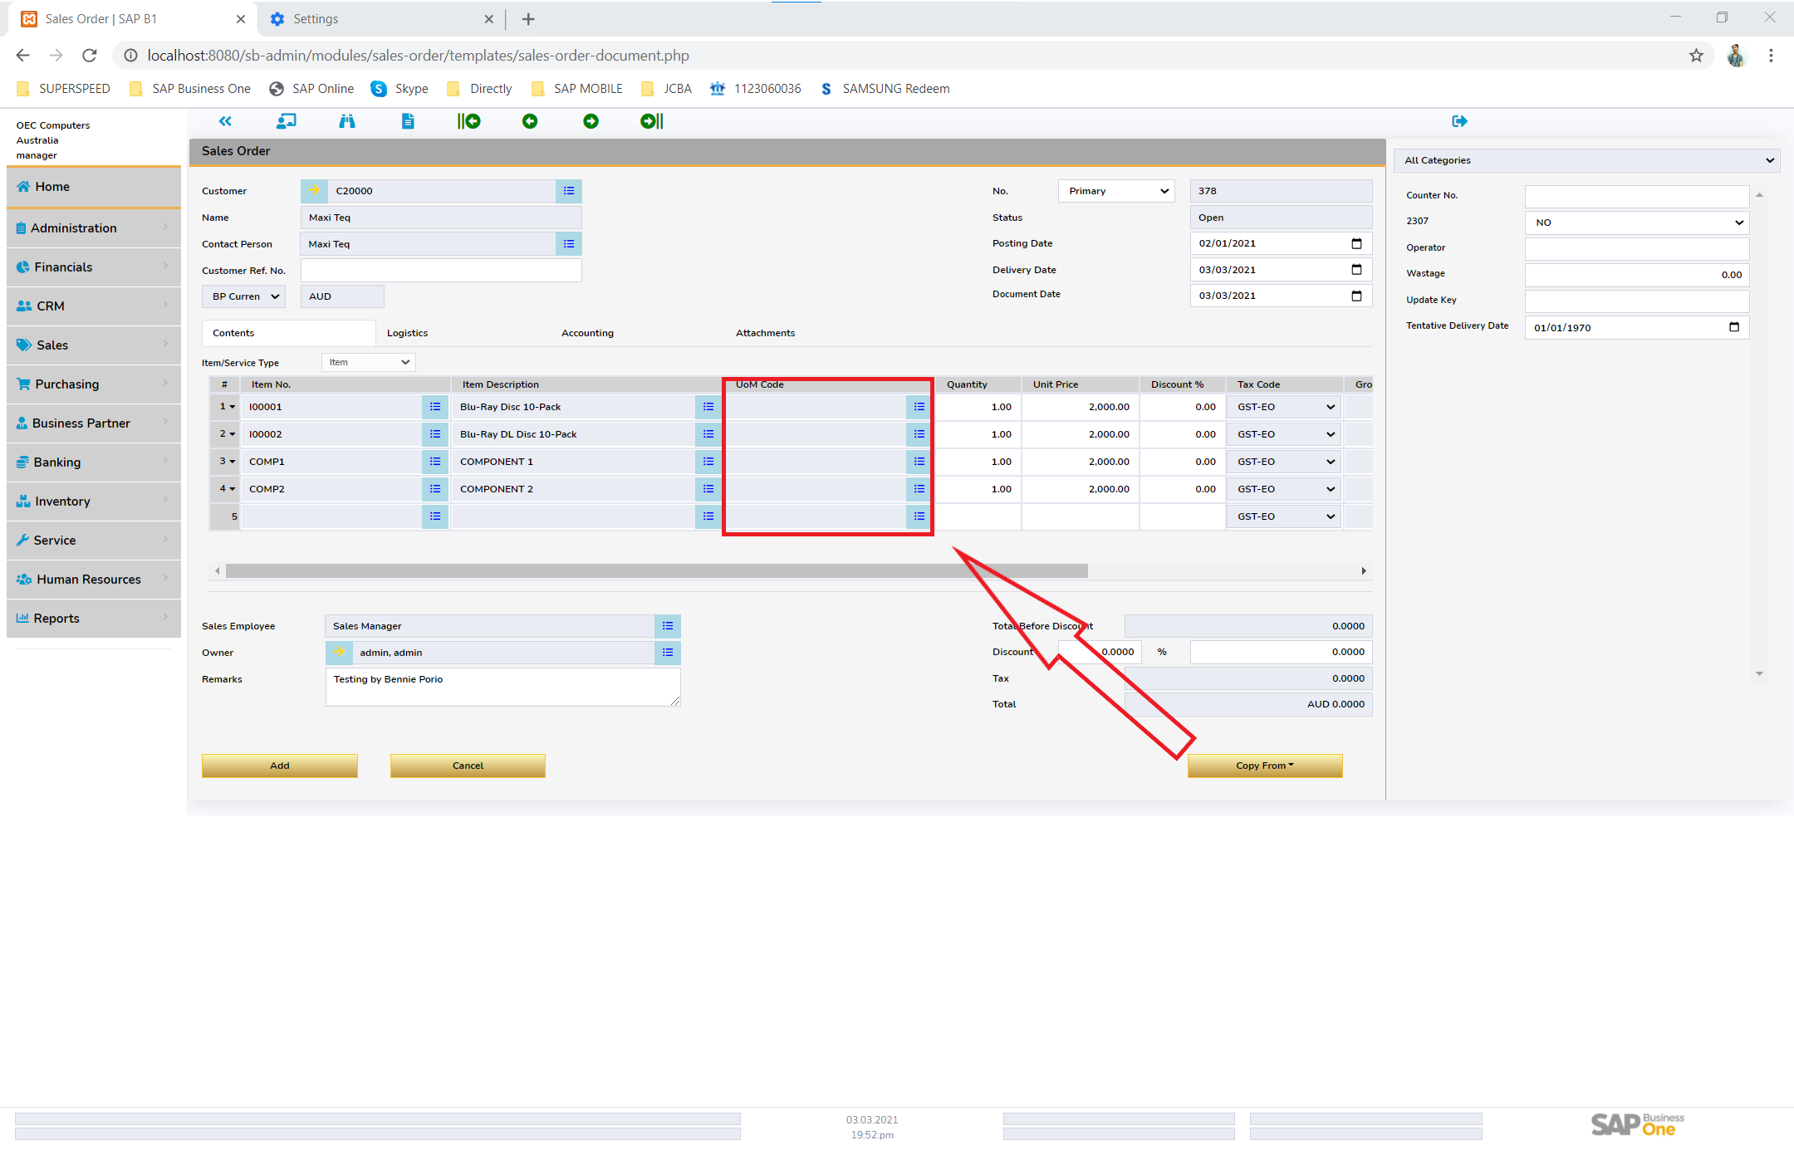

-- Copy from Function: Did not copy all information, see sample: did not copy UoM code Done

-- If I used [Copy From Function], Document number of Based Document must be automatic encoded in Remarks. Done

-- Scenario: Nag add na ako ng Sales Order, nung nag [Last Data Entry], hindi parin lumabas yung UoM Code. Pero sa SAP, Lumalabas. Done

A.5 DELIVERY – PRIORITY Done

-- Batch/Serial Tagging if OITM.MngbySerial |Batch is Yes – Mandatory Done

-- Batch Tagging

Items with batches table

- Total needed field Done

Batch Available

* Rows changeable Done

Batch Selected

* Rows changeable Done

Adding Done

Update Done

Viewing Done

Modal Error due to serial parallel

--Journal Entry Preview [Modal] PRIORITY

A.6 RETURN REQUEST - PRIORITY

A.12 RETURN - PRIORITY

-- Batch/Serial Tagging if OITM.MngbySerial |Batch is Yes – Mandatory

-- Journal Entry Preview [Modal]

A.13 A/R Down Payment Request

A.14 A/R Down Payment Invoice

-- Journal Entry Preview [Modal]

-- Copy to: A/R Credit Memo

A.15 A/R Invoice - PRIORITY

-- Batch/Serial Tagging if OITM.MngbySerial |Batch is Yes – Mandatory

-- Journal Entry Preview [Modal]

-- Footer: Total Down Payment: [Modal]

A.16 A/R Credit Memo - PRIORITY

-- Copy from

1. A/R Invoice

2. Return

[FINANCIAL]

A.17 JOURNAL ENTRY - PRIORITY

A.18 JOURNAL VOUCHER - PRIORITY

-- Save as Draft of Journal Entry – [OBTD & OBTF]

[INVENTORY]

A.23 INVENTORY TRANSFER

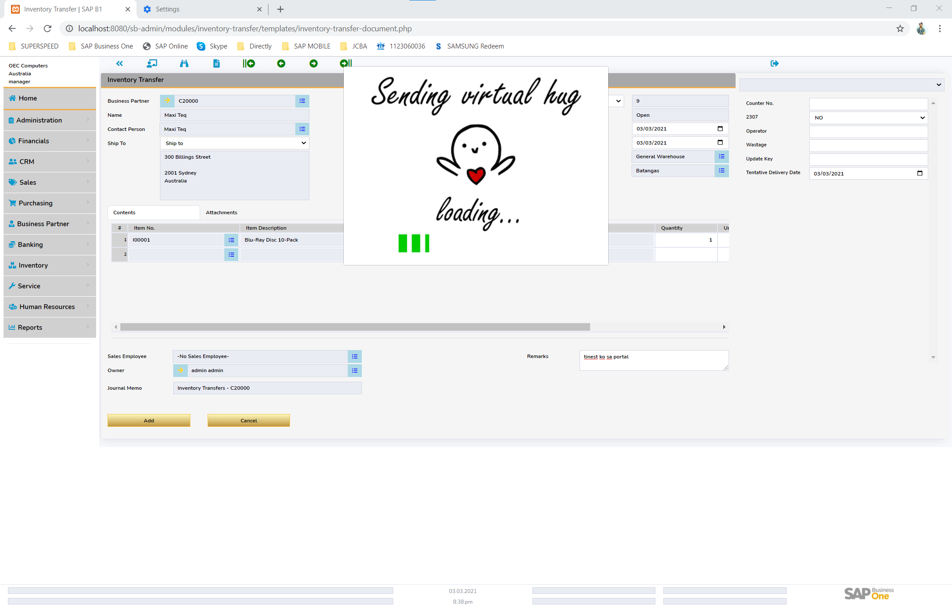

-- Hindi nag add. Done

-- Dapat hindi required yung Business Partner. Done

-- Wala dapat Unit Price – I think Item Cost but Disable. Done

A.24 Goods Receipt – PRIORITY Done

-- Journal Entry Preview [Modal]

-- Date Format must be same as SAP OADM

A.25 Goods Issue – PRIORITY Done

-- Journal Entry Preview [Modal]

A.26 Inventory Counting Transaction

A.27.1 INVENTORY COUNTING

A.27.2 INVENTORY POSTING

-- Journal Entry Preview [Modal]

A.27 REPORTS: - PRIORITY

-- Customer Ledger Balance (Please load same with PowerTrac Format and Layout)

-- (To be sent by Bennie – Other Reports)

A.28 HOME PAGE: - PRIORITY

-- Pending Request:

> Modal:

-- Populate Module Approval or Request

-- Another modal for detailed per module

> Task: REMOVE

> Background:

-- Picture JCBA

> [FOR ANTHONY] Open Document List:

-- [Golden Arrow] Doc Num | Posting Date | [Golden Arrow] Customer Name | Amount

B. ALL MATRIX

-- Item Type:

- Ano max ng Item Code na lalabas makikita sa field yung hindi lalagpas yung text. baka pwede mo paiksiin yung field. 50 characters max item code, 100 sa item name

-- Paiksiin ang UoM Code, Done

-- Auto Price in item based on the tag price list in Business Partner. Next update n lng baka may matamaan

-- Gross Price field must be editable value. Next update n lng baka may matamaan

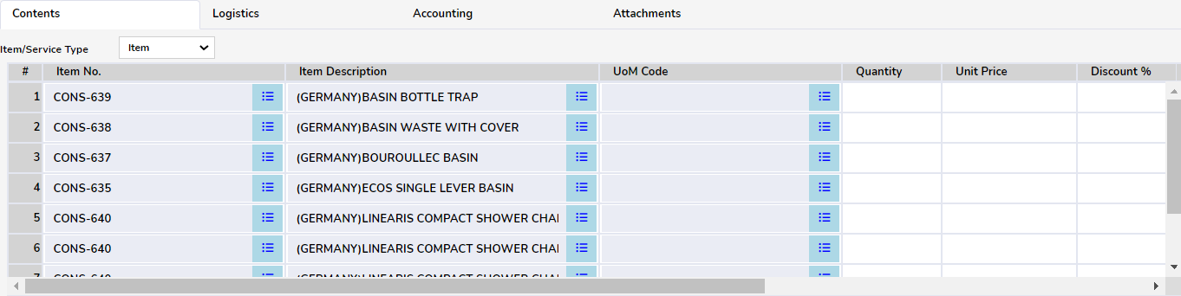

- baka mapapaliit mo pa yung height ng row. Still fiinding a way because whole table is affected

- UoM, sobrang lapad din. Paiksiin mo yung width. . Done

- Delete Row: Maganda pag nag right click nandun yung delete row Done but not right click

- Yung Duplicate, hindi nagwowork ? Figuring Out how will I do it

- Pwede kaya tayo maglagay ng form setting?

- If Item is a Sales Item, it should only show in Sales Transactions and All Inventory Transactions. If Item is a Purchase Item, it should only show in Purchase Transactions and All inventory Transactions. If both are Sales Item and Purchase Item, they are shows for both Sales and Purchase Transaction. Done

-- In Service Type:

- Format: Description | G/L Account Code | G/L Account Name | Preferred Vendor | Required Date | Unit Price | Discount | Tax Code | Gross Amount | Total | Gross Total Done

-- Attachment REMOVE

- Should be blank, will not show content tab Done

> Only Purchase Order applied

-- Copy paste function from Excel to Webportal. AFTER DR

-- [#] put space to left

-- Arrow in Data Table of Sort By: Remove the other Line Arrow icon Done

C. ALL HEADER AND FOOTER

- No. series, dapat naka default base sa Document Numbering ni SAP; Default Primary Done

- Number series, hindi lumabas for primary. Done

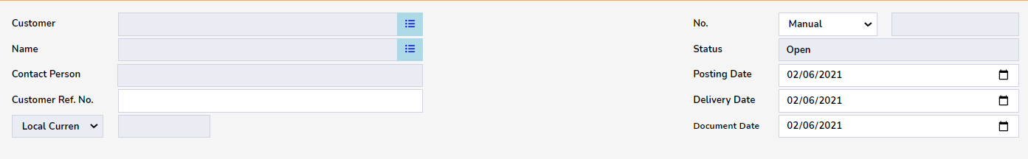

- Dates; Sobrang Lapad – 10 Characters lang naman yan Done

- Dates; Date format must be same with SAP Business One Application format. Cannot be. Browser standard date format is 02/02/2020

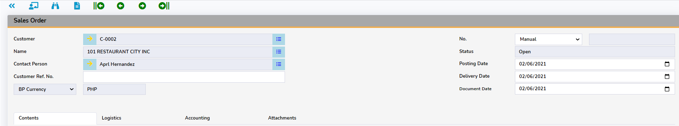

- Para saan yung Link arrow ng Contact Person ? If no purpose, remove. Feature coming soon

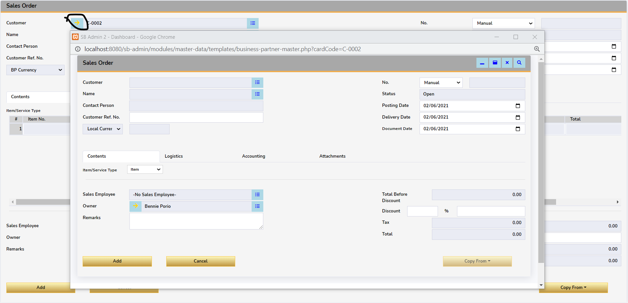

- Pag clinic ko yung Arrow button, may lumabas na ganyan. Dapat ba Customer Master Data ‘to instead another Sales Order? Please enlighten me. Yes it will open master data in other window Feature coming soon. – Ongoing? When is the target date? Least Priority

- Add Rounding Field in both SQ and SO. Ano to?

- By Default; Show UDF Field when opening document Done

-- Scenario:

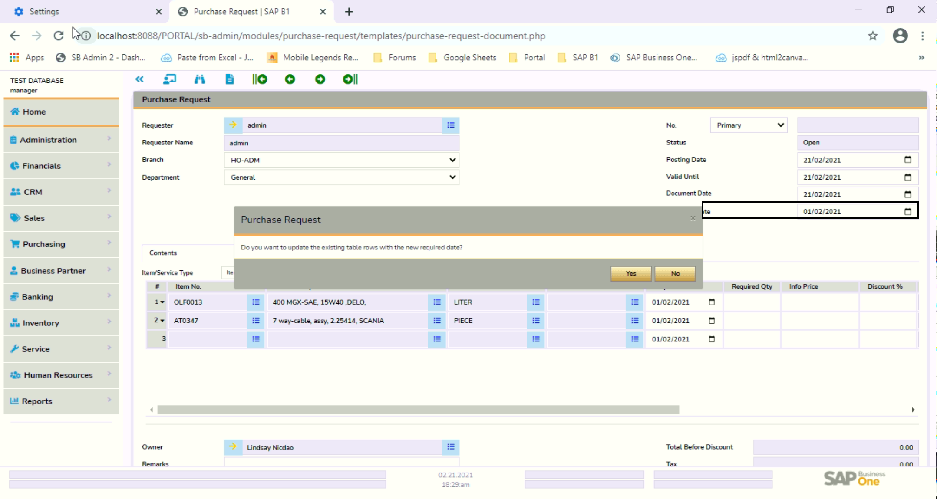

- Before I can complete the change of date, Notification to update date row pops up. Done

-- Changing Date: Pag nagchange ako ng Posting Date, mache-change din ang document date. Pero pag nagchange ng Document date, hindi mache-change ang Posting Date. Done

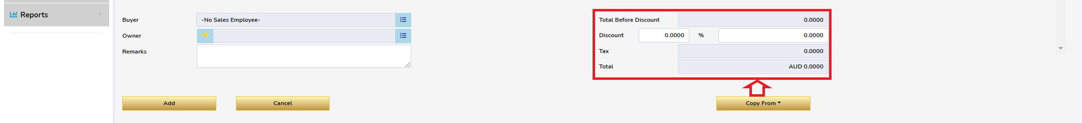

-- Nag copy from ako from [SQ or PR], pero hindi nacopy yung Doc Total Done

-- [Copy from] Doc number Is missing when we do copy from function.

-- [Button: Update] Default “OK”, pag may nabago lang saka machange yung “OK” to “Update”.

-- Copy to Functions in All Document

D. NOTIFICATION, FUNCTIONS AND SECURITIES:

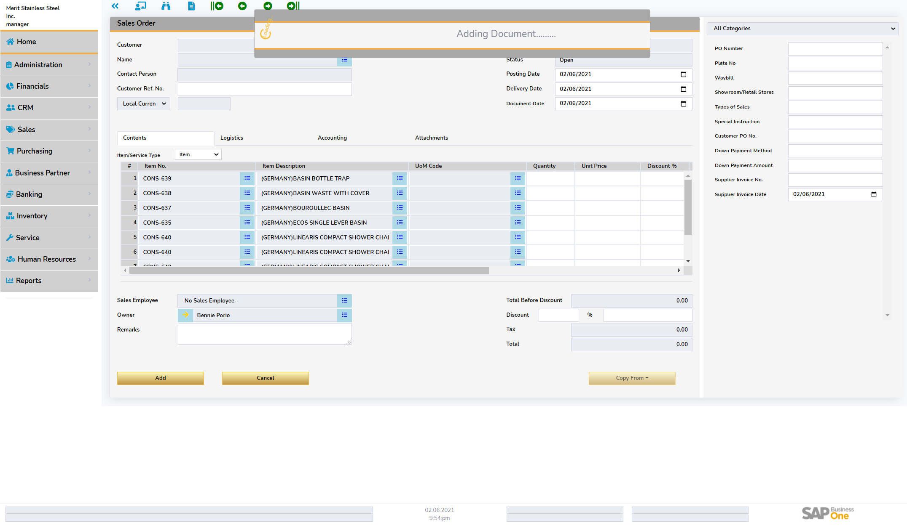

* Encounter: Loading lang kasi walang Customer Code Done
* Dapat may error message na agad pag hindi nalagyan ng Customer. Done
* Dapat before makalagay sa Item, priority first na mainput yung Customer Field like SAP. Done

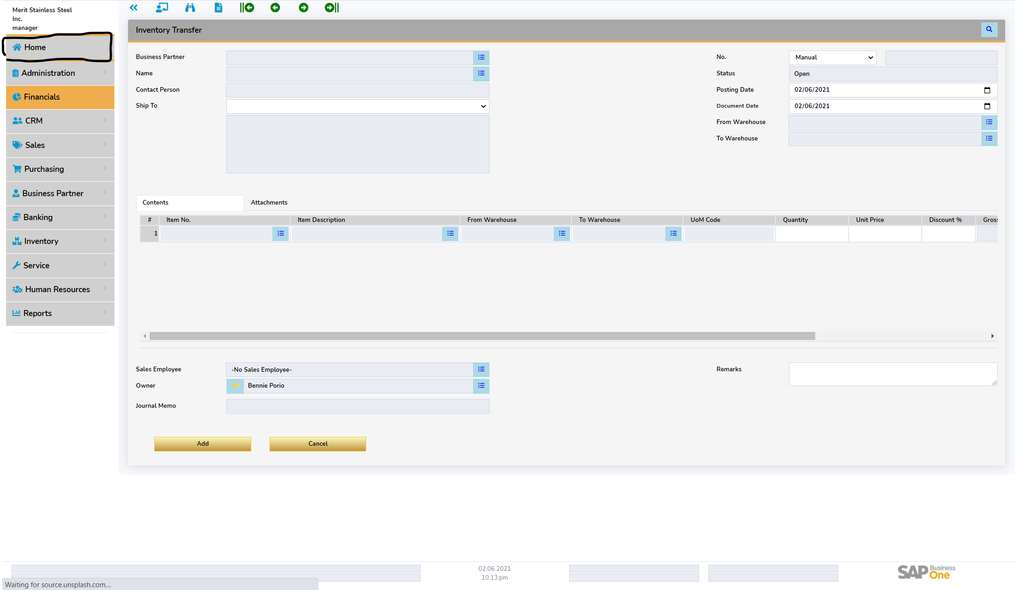

- Home or Dashboard Functions is not working Done

- Log out or Screen Lock function Done

- Hide/Unhide Modules Window Done

- Adding notification; masyadong makapal Changed Type of Loading Please give feedback on new loading. – Palitan mo yung Notification Load. Done PALITAN MO ULIT

-- Pag nag refreish ako, babalik sa Home Function if gawin to, matatamaan new document button

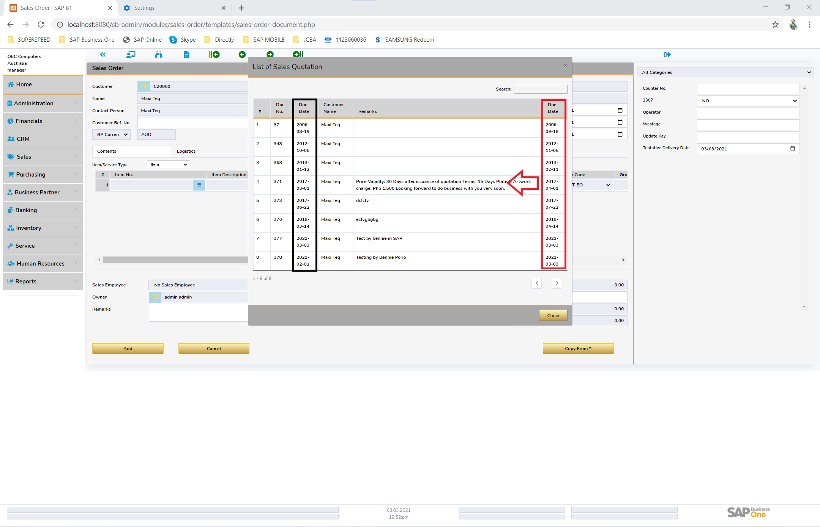

-- List of Sales Quotation: [Date] Change format based on SAP Business One Browser Input Field doesn’t allow dots

-- List of Sales Quotation: [Due Date] move beside Doc Date Done

-- Form Setting Function

-- Yung Licensing, Paunahan kung sino ang makakalog in.

-- Licensing Program

> 15 Users

> 30 Users

> Unlimited Users

-- [FOR ANTHONY]

> Busines Partner Master Data: Viewing Only

-- Another Tab once click

-- Cardcode golden arrow link to BP Master Data

E. MODULE:

- Please add; Inventory Transfer Request Ongoing

- 3 Seconds before users can use Transaction module. Can we shorten this loading? This is because we are using pc

- User Management; When will this be update? Can we set meeting for this? Baka may idea ka na iba dun sa existing natin dati

- We should have [Tab] : User Group | Authorization (I will think about what we will include to this) | Approval Need more discussion

[--ADMINISTRATION MODULE--]

“USER MANAGEMENT”

{HEADER}

Superuser: [Y/N] Done

> If Superuser is No, administration module cannot be Access Done

User Code Done

User Name Done

Password Done

Employee [Employee Master Data in SAP] Done

Locked: [Y/N] Done

[Tab 1: Module Access/Authorization] Done

+ [Y/N] General Setting

- [Y/N] Cancellation of Document

- [Y/N] Manual Closing

+ [Y/N] Sales Module

- [Y/N] Sales Quotation

- [Y/N] Sales Order

+ [Y/N] Purchase Module

- [Y/N] Purchase Request

- [Y/N] Purchase Order

+ [Y/N] Inventory Module

- [Y/N] Inventory Transfer

> Sa Select All: mag black siya kapag , may 1 na sub-item na hindi naka-select

> Scenario in testing: kapag nag-unselect ako ng sub-item, naka-unselect yung “select all”

[Tab 2: Approval] - PRIORITY

-- [Tab A: Document]

-- [Tab B: Approver]

-- Multiple per Row (For ‘or’ Approver)

-- Per Row is 1st, 2nd, and etc.

-- [Tab C: Terms]

- Show only users created in specific Database – PRIORITY

“LICENSE MANAGEMENT” - PRIORITY

- Same function as SAP Business One Connected Clients

F. INTERFACE:

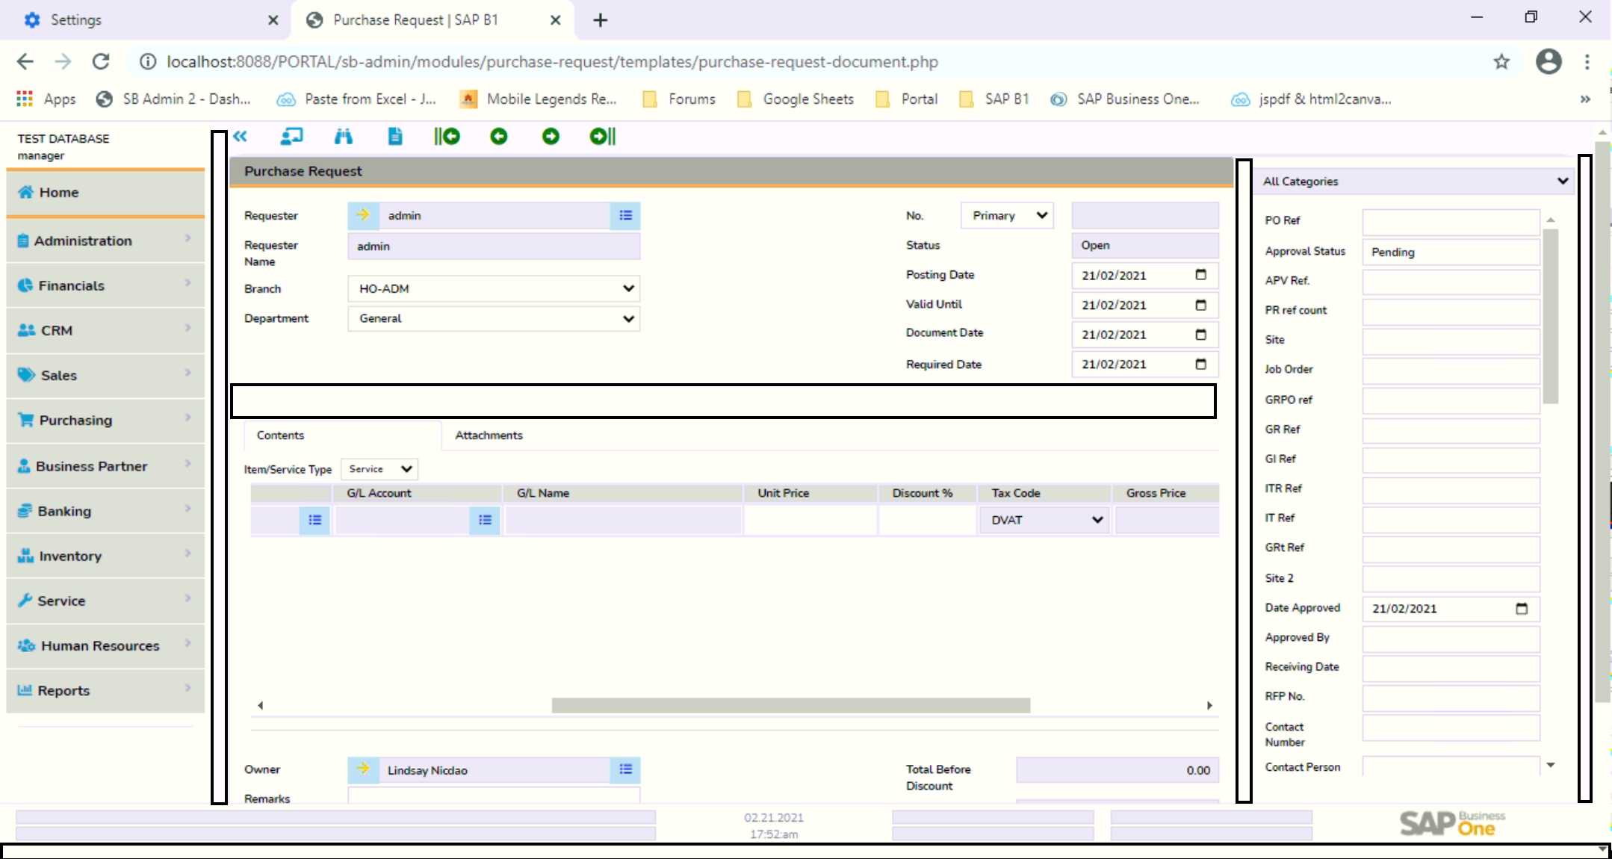

- Paiksiin mo yan ito. Done

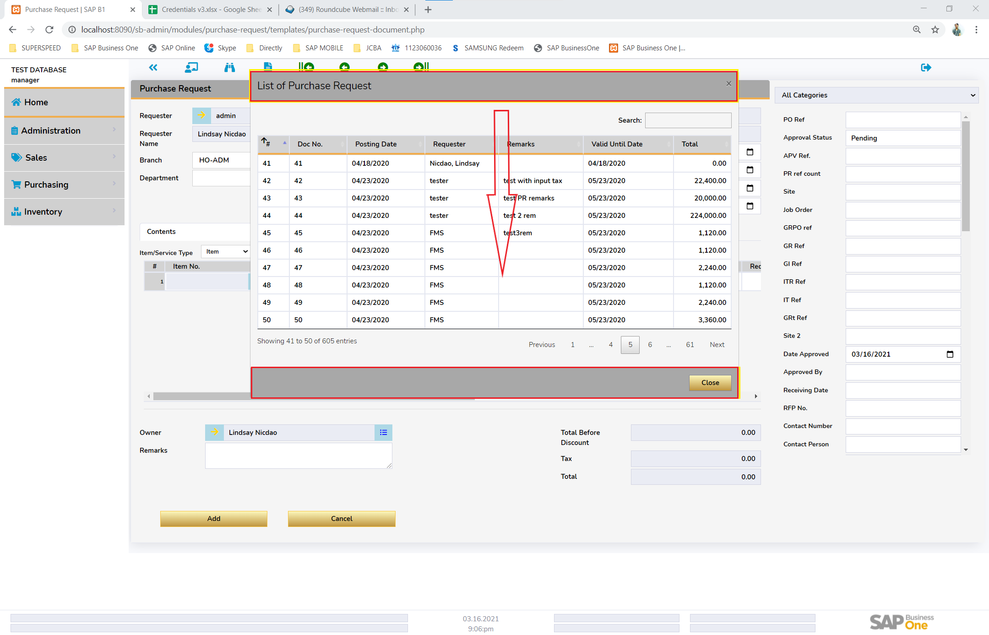

- Panipisin ang header and footer ng Modal Done

- [Arrow down] Pababain mo pa yung Modal. Dapat kita yung Tool Bar Done

- Remove excess arrow in Header Matrix

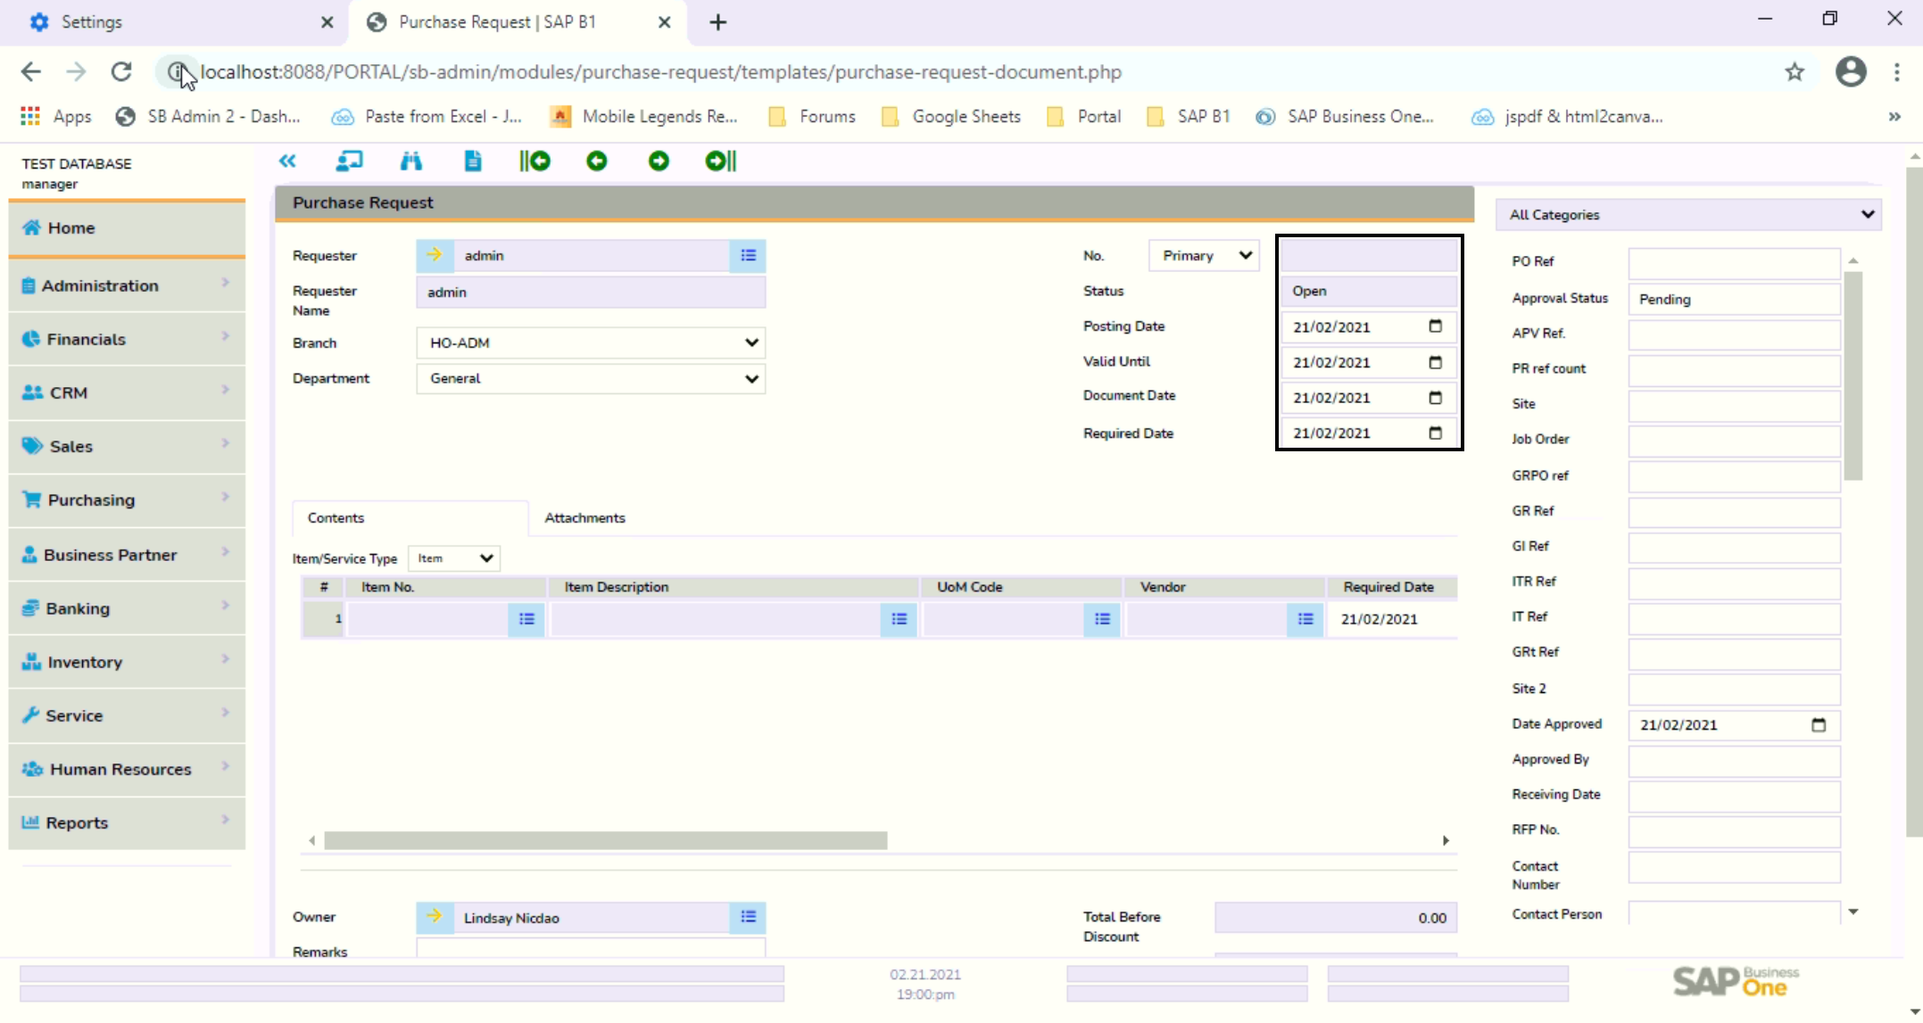

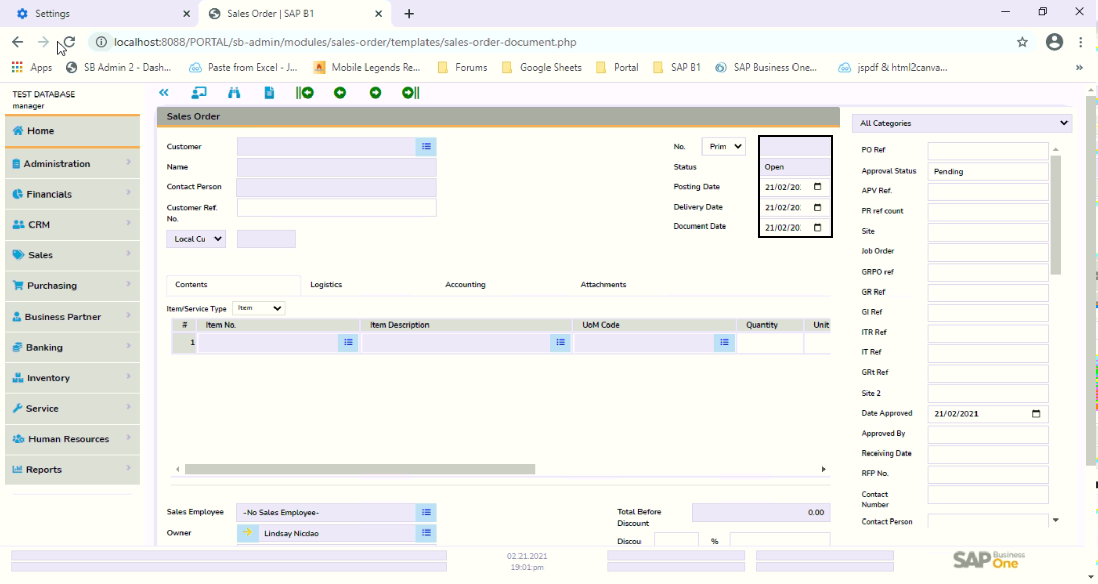

- Dates; Size for Sales and Purchase Document are not the same. Done

G. [FOR BENEDICT] FORMS AND LAYOUT REPORT:

- Sample Syntax for HTML sent to Benedict  
 - Tuesday/ Wednesday expected checking

- Purchase Request

> For Design by Bennie

- Purchase Order

> Sent to Anthony

- Goods Receipt PO

> For Design by Bennie

- Sales Quotation

> For Design by Bennie

- Sales Order

> Sent to Anthony

- Delivery

> Sent to Anthony

- Inventory Transfer

> For Design by Bennie

- Goods Issue

> For Design by Bennie

- Goods Receipt

> For Design by Bennie

MAY 23, 2021 Notes

ALISIN ATTACHMENT ALL MODULES Done

EXP date, Mfr Date default sa null Done

hide batch container Done

unique field serial/batch/lot SriUnqFld adminstartion > general settings > inventory default Done

warehouse oitm pag wala dun ka sa adminstartion > general settings > inventory (OADM) serial 1 quantyity remove Done

created batches cerated quantity delete Done

row in batch and serial

geneal ledger text field not input from powertrac

OADM DateFormat ONLY DECIMAL ADD ROUNDING

September 12 2021

Rows item search on input

10/10/2021

JOSHUA

LICENSE FINAL OUTPUT (Oct 20,2021)

GOODS RECEIPT (Oct 13,2021)

GOODS ISSUE(Oct 14,2021)

E BINGGAY ADD ON

AR (7z) (Oct 23,2021)

AP Excel Uploader) (Oct 23,2021)

IP Excel Uploader (PDF Issue) ) (Oct 23,2021)

BENEDICT

DASHBOARD

SESSION STORAGE (JQUERY/JAVASCRIPT) & PHP COOKIES – LICENSE SYSTEM (Oct 13,2021)

AP INVOICE (Oct 16,2021)

AP DOWNPAYMENT (Oct 17,2021)

AR INVOICE(Oct 16,2021)

AR DOWNPAYMENT(Oct 17,2021)

ANTHONY

COOKIES (PHP) – LICENSE SYSTEM (Oct 13,2021)

CRYSTAL ON PORTAL (Oct 14,2021)

DEMONSTRATE TO JOY OCT 23 / OCT 24 , 2021